**Project Proposal: Authentication Key Generator**

**Goal:** To build an application with an easy to use UI that will utilize OMNIKEY 5022 Reader and MIFARE Classic EV1 to generate unique authentication keys for possible school and campus cards purposes.

**Use Cases**

* Utilize OMNIKEY to read in MIFARE Classic Cards
* Be able edit/update sectors/blocks
* Generate authentication keys for handshake protocol

**Tools:**

* Linux/PC Computer
* Text Editor/IDE compatible with C#
* Knowledge in C#*

* (Does not necessarily have to be coded in C# but a prototype application for this project was in C# and could serve as a starting block)

**Point of Contact:**

Rick Fox

Access Control/Life Safety Manager

[rwfox@coloradomesa.edu](mailto:rwfox@coloradomesa.edu)

970-248-1269

**Hardware**

* **MIFARE Classic EV1 1k - Mainstream contactless smart card**
  + # of sectors = 16
  + Sectors(0-15) := 1 sector = 4 Blocks = 64bytes
    - 1 Byte = 8 bits
    - ASCII = 1 byte per character
  + Architecture:

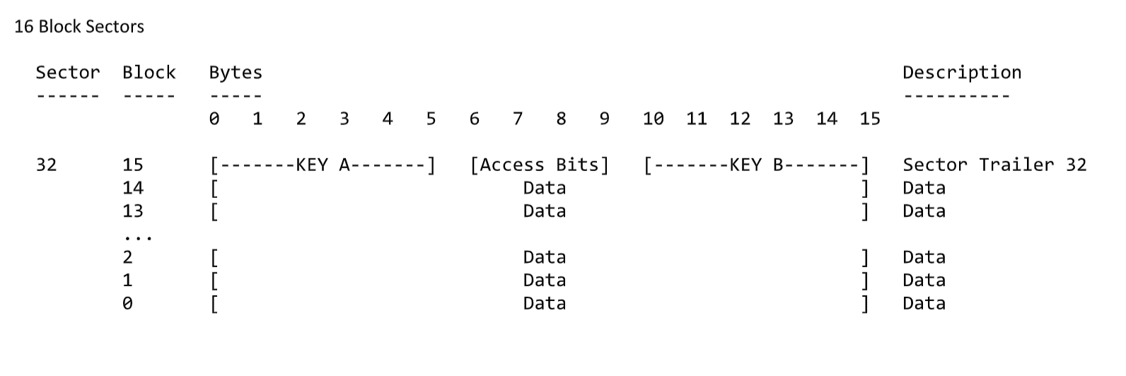

* + Manufacturer programmed 7-byte UID or 4-byte NUID identifier for each device
  + Contactless transmission of data and energy supply
* **OMNIKEY 5022 Reader**
  + can work with Windows and Linux OS ( driver download might be required
  + CCID (Circuit Card Interface Device) support
  + Support common high frequency card technologies, including MIFARE
  + USB 2.0 specification
  + supports a single polling mode
  + (See polling operation below)

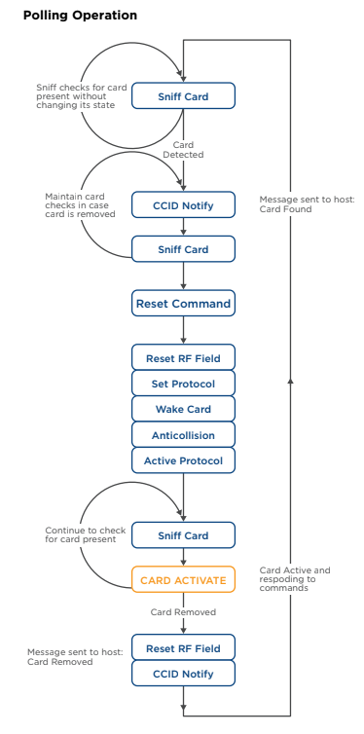

Resources:

* OMNIKEY: <https://hidglobal.com/support>
* MIFARE: <http://www.nxp.com>
* <http://pcscworkgroup.com/Download/Specifications/pcsc3_v2.01.09_amd1.pdf>